Treasury Management Policy Statement 2020/21

- PURPOSE OF THE REPORT

To present the Prudential and Treasury Indicators and Treasury Management and Investment Strategies for 2020/21 to 2023/24, and the Minimum Revenue Policy Statement for 2020/21.

- BACKGROUND TO THE REPORT

  - For each financial year the Council sets a balanced budget so that cash income raised during the year is sufficient to meet all its cash expenditure commitments. One of the key functions of the Council’s treasury management activity is to ensure that these cash flows are effectively managed, so that cash is available when it is needed. Surplus cash is invested having regard to risk, liquidity and yield.

  - A further key function of the treasury management activity is to ensure that the Council has sufficient funds to pay for its capital and other investment plans. These capital plans, which are set out in the Capital Programme, identify the borrowing needs of the Council over a longer time horizon than the current year. In managing its longer-term cash flow requirements for capital expenditure, the Council will take out loans or alternatively use its cash flow surpluses in lieu of external borrowing. This latter practice is referred to as “internal borrowing”. In managing its loans, it may at times be advantageous for the Council to repay or restructure its borrowings to optimise interest payments or achieve a balanced debt portfolio.

  - Having regard to these activities, the Chartered Institute of Public Finance and Accountancy (CIPFA) defines treasury management as:

“The management of the Council’s investments and cash flows, its banking, money market and capital market transactions; the effective control of the risks associated with those activities; and the pursuit of optimum performance consistent with those risks.”

  - As treasury management decisions involve borrowing and investing substantial sums of money, the Council is exposed to potentially large financial risks, including the loss of invested funds and the revenue effect of changing interest rates. The identification, control and monitoring of risk are therefore integral elements of treasury management activity.

  - The Treasury Management Policy Statement for 2020/21 is based upon the Chief Finance Officer and Treasury Officers’ views on interest rates supplemented by leading market forecasts. The policy statement covers:

- The policy for managing capital borrowing and debt rescheduling
- The annual investment strategy for treasury management investments
- Reporting arrangements
- Training arrangements
- Performance indicators
- Minimum Revenue Provision (MRP) Policy
- Use of treasury management advisors

  - Council of 27 February 2019 approved the Treasury Management Strategy for 2019/20, including Prudential and Treasury Indicators, the Treasury Management and Investment Strategies, and the annual Minimum Revenue Provision (MRP) Policy Statement for 2019/20. Treasury Management activities during the year have been overseen by the Governance Committee.

  - One change to Investment Counterparties is proposed, i.e. the removal of the restriction of the use of non-UK banks to those within the EU (see paragraph 8.3). The criteria in respect of the credit ratings for the individual country and institution would remain unchanged, as would the overall limits for investments in non-UK banks. No changes to counterparty limits are proposed.

  - This report updates Prudential and Treasury Indicators for financial years 2019/20 to 2023/24. It presents updated Treasury Management and Investment Strategies and proposes the Minimum Revenue Policy Statement for 2020/21.

- TREASURY MANAGEMENT STRATEGY 2020/21

  - The strategy for 2020/21 covers two main areas:

Capital issues
- the capital plans and the Prudential Indicators;
- the Minimum Revenue Provision (MRP) policy.

Treasury management issues
- the current treasury position;
- Treasury Indicators which limit the treasury risk and activities of the Council;
- prospects for interest rates;
- the borrowing strategy;
- policy on borrowing in advance of need;
- debt rescheduling;
- the investment strategy;
- creditworthiness policy; and
- the policy on use of external service providers.

  - These elements cover the requirements of the Local Government Act 2003, the CIPFA Prudential Code, MHCLG MRP Guidance, the CIPFA Treasury Management Code, and MHCLG Investment Guidance.

  - The Statutory Guidance on Minimum Revenue Provision remains the 3rd edition, as issued by the Ministry of Housing, Communities & Local Government on 2 February 2018.

- TRAINING

  - The CIPFA Code requires the Responsible Officer to ensure that members with responsibility for treasury management receive adequate training in treasury management. This especially applies to members responsible for scrutiny. Training will be provided on the implications of the revised CIPFA Prudential and Treasury Management Codes, and the revised MHCLG Investment Guidance and MRP Guidance.

  - The training needs of treasury management officers are reviewed periodically. Both CIPFA and Link Asset Services provide workshops and seminars.

- TREASURY MANAGEMENT CONSULTANTS

  - The Council uses Link Asset Services, Treasury Solutions as its external treasury management advisors. The advisors provide access to specialist skills and resources including

- Technical support on treasury matters and capital finance issues.
- Economic and interest rate analysis.
- Debt services, which includes advice on the timing of borrowing.
- Debt rescheduling advice surrounding the existing portfolio.
- Generic investment advice on interest rates, timing and investment instruments.
- Credit ratings/market information service comprising the three main credit rating agencies.

  - The Council recognises that responsibility for treasury management decisions always remains with the organisation and will ensure that undue reliance is not placed upon our external service providers.

  - The Council will ensure that the terms of their appointment and the methods by which their value will be assessed are properly agreed, documented and subjected to regular review.

- CAPITAL PRUDENTIAL INDICATORS 2019/20 – 2023/24 and mrp statement

  - The Council’s capital expenditure plans are the key driver of treasury management activity. The output of the capital expenditure plans is reflected in the prudential indicators, which are designed to assist members’ overview and confirm capital expenditure plans.

  - Capital expenditure

This prudential indicator is a summary of the Council’s capital expenditure plans, both those agreed previously, and those forming part of this budget cycle.

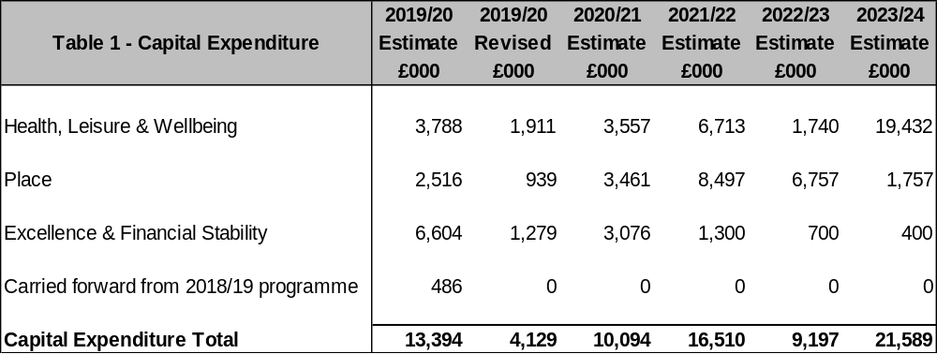
The table below summarises the above capital expenditure plans identified in the Capital & Investment Strategy and the Capital Programme and how these plans are being financed by capital or revenue resources. Any shortfall of resources results in a borrowing requirement.
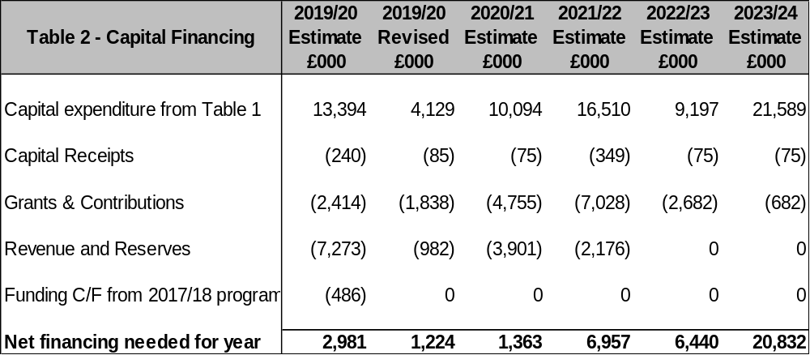
The Council’s borrowing need (the Capital Financing Requirement)

The second prudential indicator is the Council’s Capital Financing Requirement (CFR). The CFR is simply the total historic outstanding capital expenditure which has not yet been paid for from either revenue or capital resources. It is essentially a measure of the Council’s indebtedness and so its underlying borrowing need. Any capital expenditure above, which has not immediately been paid for, will increase the CFR.

The CFR does not increase indefinitely, as the Minimum Revenue Provision (MRP) is a statutory annual revenue charge which broadly reduces the indebtedness in line with each asset’s life, and so charges the economic consumption of capital assets as they are used.

The CFR includes any other long-term liabilities (finance leases). Whilst these increase the CFR, and therefore the Council’s borrowing requirement, these types of scheme include a borrowing facility by the lease provider and so the Council is not required to separately borrow for these schemes:

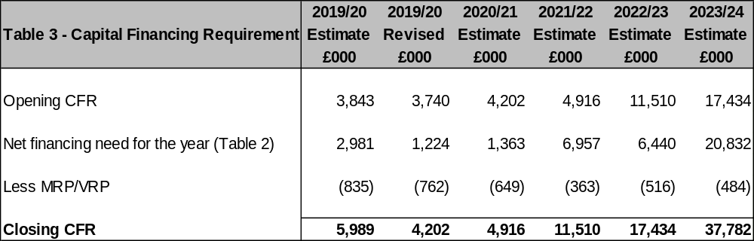

  - Minimum Revenue Provision (MRP)

The Council has a statutory requirement to set aside each year part of their revenues as a provision for the repayment of debt, called the Minimum Revenue Provision (MRP). The provision is in respect of capital expenditure incurred in previous years and which has been financed by borrowing.

The statutory requirement per the Local Authorities (Capital Finance and Accounting) (England) (Amendment) Regulations 2008 [SI 2008/414] is for each local authority to determine an amount of MRP which it considers to be “prudent”.

As “prudence” is not defined in the regulations, the MHCLG had issued accompanying statutory guidance which explains that the broad aim of a “prudent provision” is to ensure that the debt is repaid over a period that is either, reasonably commensurate with the period over which the capital expenditure provides benefit, or, in the case of borrowing supported by formula grant, reasonably commensurate with the period implicit in the determination of that grant. Each authority must determine what they consider is a prudent amount while having regard to the guidance.

The guidance also recommends that each local authority prepare an annual statement of its strategic policy on making MRP, to be approved by the full Council. A variety of options are provided to councils in the regulations, so long as there is a prudent provision.

For capital expenditure incurred before 1 April 2008 Option 1 is applied.

This provides for local authorities to continue to calculate MRP in line with the minimum existing statutory charge of 4% of outstanding debt related to supported borrowing only, less an adjustment that ensures consistency with previous capital regulatory regimes no longer in force.

From 1 April 2008 for all unsupported borrowing (including finance leases) the MRP policy will be Option 3 – Asset Life Method

This method is appropriate for calculating MRP in relation to debt incurred as unsupported borrowing (also known as prudential borrowing) and must be used for revenue expenditure capitalised by direction or regulation. Under this option there are two methods available:

- (Equal instalment method. This generates a series of equal annual amounts over the life of each asset that is financed by borrowing, with the life determined upon acquisition. This means that the charge to revenue closely matches the period of economic benefit of the asset.
- Annuity method. This method links the MRP to the flow of benefits from an asset where the benefit is expected to increase in later years.

Under this option, authorities should consider the type of assets that they finance through prudential borrowing, as the type of asset and its useful life may have a significant impact on the level of MRP charged. Where expenditure is capitalised by direction or regulation, the guidance specifies certain maximum lives to be used in the calculation.

Finance Leases and PFI
The guidance indicates that for finance leases and on-balance sheet PFI contracts, the MRP requirement could be met by making a charge equal to the element of the finance lease rental that goes to write down the balance sheet liability under proper accounting practices.

  - Affordability prudential indicators

The previous sections cover the overall capital and control of borrowing prudential indicators, but within this framework prudential indicators are required to assess the affordability of the capital investment plans. These provide an indication of the impact of the capital investment plans on the Council’s overall finances. The Council is asked to approve the following indicator:

Ratio of financing costs to net revenue stream

This indicator identifies the trend in the cost of capital (borrowing and other long-term obligation costs net of investment income) against the net revenue stream.

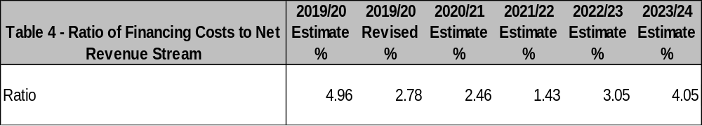
The estimates of financing costs include current capital commitments and the proposals in the Budget and Capital and Investment Strategy reports. The increasing ratio for the remainder of the budget period reflects the additional level of borrowing required to finance the Council’s planned Capital Programme. However, the intention for schemes funded through borrowing is that they will, where possible, deliver a financial return and therefore contribute to the sustainability of the Council’s debt financing costs.

  - Core funds and expected investment balances

The application of resources (capital receipts, reserves etc.) to either finance capital expenditure or other budget decisions to support the revenue budget will have an ongoing impact on investments unless resources are supplemented each year from new sources (asset sales etc.).

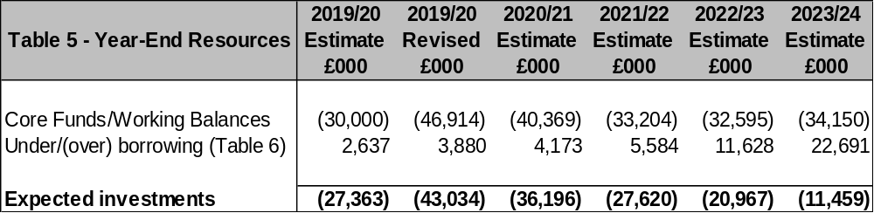

- borrowing

  - The capital expenditure plans set out in paragraph 6.2 above provide details of the service activity of the Council. The treasury management function ensures that the Council’s cash is organised in accordance with the relevant professional codes, so that sufficient cash is available to meet this service activity and the Council’s capital strategy. This will involve both the organisation of the cash flow and, where capital plans require, the organisation of appropriate borrowing facilities. The strategy covers the relevant Treasury / Prudential Indicators, the current and projected debt positions and the annual Investment Strategy.

  - Current portfolio position

  - The Council’s treasury portfolio position at 31 March 2019, with forward projections, is summarised below. The table shows the actual external debt (the treasury management operations), against the underlying capital borrowing need (the Capital Financing Requirement - CFR), highlighting any over or under borrowing.

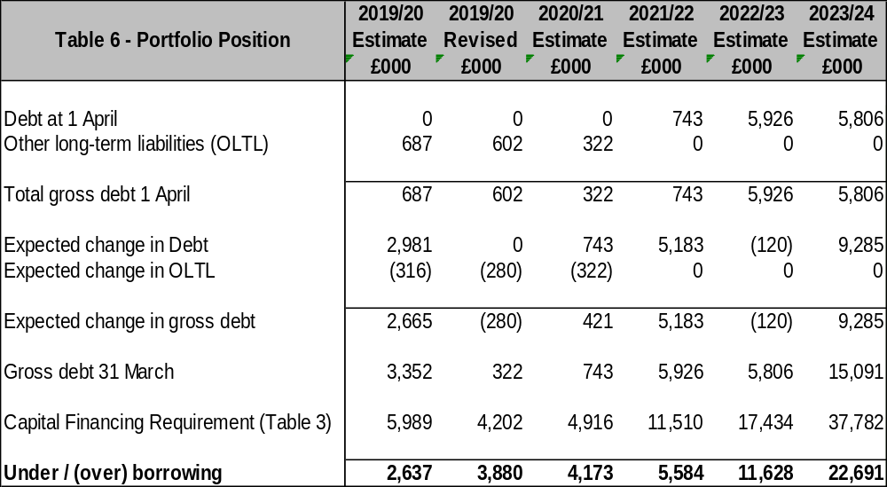
  - Within the prudential indicators there are a number of key indicators to ensure that the Council operates its activities within well-defined limits. One of these is that the Council needs to ensure that its gross debt does not, except in the short term, exceed the total of the CFR in the preceding year plus the estimates of any additional CFR for 2019/20 and the following two financial years. This allows some flexibility for limited early borrowing for future years but ensures that borrowing is not undertaken for revenue or speculative purposes.

  - The Council complied with this prudential indicator in the current year and does not envisage difficulties for the future. This view takes into account current commitments, existing plans, and the proposals in this budget report.

  - Treasury Indicators: limits to borrowing activity

The Operational Boundary. This is the limit beyond which external debt is not normally expected to exceed. In most cases, this would be a similar figure to the CFR, but may be lower or higher depending on the levels of actual debt and the ability to fund under-borrowing by other cash resources.

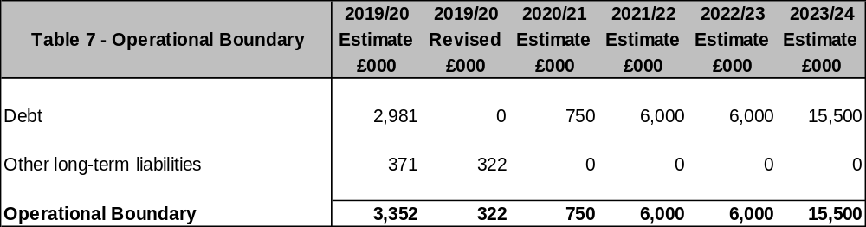
The Authorised Limit for external debt. A further key prudential indicator represents a control on the maximum level of borrowing. This represents a limit beyond which external debt is prohibited, and this limit needs to be set or revised by the full Council. It reflects the level of external debt which, while not desired, could be afforded in the short term, but is not sustainable in the longer term.

- This is the statutory limit determined under section 3 (1) of the Local Government Act 2003. The Government retains an option to control either the total of all councils’ plans, or those of a specific council, although this power has not yet been exercised.

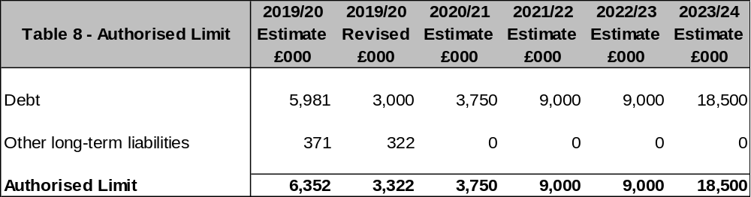
  - Maturity structure of borrowing

These gross limits are set to reduce the Council’s exposure to large fixed rate sums falling due for refinancing and are required for upper and lower limits.

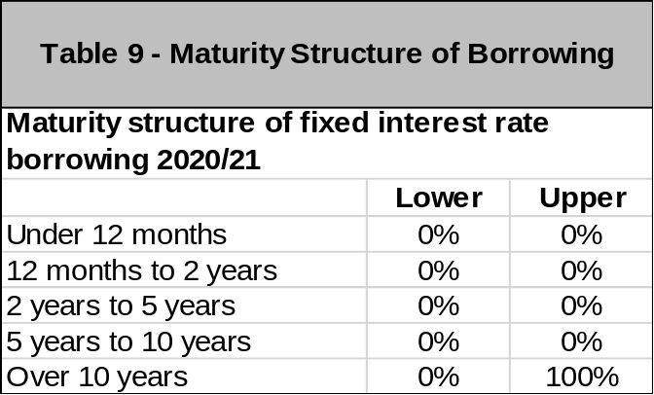

It is not anticipated that any borrowing will be taken at variable interest rates.

  - Control of interest rate exposure

Please see paragraphs 7.9, 8.4 and Appendices D1-3.

Appendix D3 compares the forecast of a year ago with that prepared for the mid-year review, and the current forecast.

  - Borrowing strategy

The Council is currently maintaining an under-borrowed position. This means that the capital borrowing need (the Capital Financing Requirement), has not been fully funded with loan debt as cash supporting the Council’s reserves, balances and cash flow has been used as a temporary measure. This strategy is prudent as investment returns are low and counterparty risk is still an issue that needs to be considered.

Against this background and the risks within the economic forecast, caution will be adopted with the 2020/21 treasury operations. The Section 151 Officer will monitor interest rates in financial markets and adopt a pragmatic approach to changing circumstances:

- if it was felt that there was a significant risk of a sharp FALL in borrowing rates, (e.g. due to a marked increase of risks around relapse into recession or of risks of deflation), then borrowing will be postponed.

- if it was felt that there was a significant risk of a much sharper RISE in borrowing rates than that currently forecast, perhaps arising from an acceleration in the rate of increase in central rates in the USA and UK, an increase in world economic activity, or a sudden increase in inflation risks, then the portfolio position will be re-appraised. Most likely, fixed rate funding will be drawn whilst interest rates are lower than they are projected to be in the next few years.

Any decisions will be reported at the next available opportunity.

  - Policy on borrowing in advance of need

The Council will not borrow more than or in advance of its needs purely in order to profit from the investment of the extra sums borrowed. Any decision to borrow in advance will be within forward approved Capital Financing Requirement estimates and will be considered carefully to ensure that value for money can be demonstrated and that the Council can ensure the security of such funds.

Risks associated with any borrowing in advance activity will be subject to prior appraisal and subsequent reporting through the mid-year or annual reporting mechanism.

- annual investment strategy

  - Investment Policy

The Council’s investment policy has regard to the CLG’s Guidance on Local Government Investments (“the Guidance”) and the CIPFA Treasury Management in Public Services Code of Practice and Cross Sectoral Guidance Notes 2017 (“the CIPFA TM Code”). The Council’s investment priorities will be Security first, portfolio Liquidity second, and only then return (Yield).

In accordance with the above guidance from the CLG and CIPFA, and in order to minimise the risk to investments, the Council applies minimum acceptable credit criteria in order to generate a list of highly creditworthy counterparties which also enables diversification and thus avoidance of concentration risk. The key ratings used to monitor counterparties are the Short Term and Long Term ratings.

Ratings will not be the sole determinant of the quality of an institution; it is important to continually assess and monitor the financial sector on both a micro and macro basis and in relation to the economic and political environments in which institutions operate. The assessment will also take account of information that reflects the opinion of the markets. To achieve this consideration the Council will engage with its advisors to maintain a monitor on market pricing such as “credit default swaps” and overlay that information on top of the credit ratings.

Other information sources used will include the financial press, share price and other such information pertaining to the banking sector in order to establish the most robust scrutiny process on the suitability of potential investment counterparties.

Treasury Management Practice 1 (TMP1) deals with credit and counterparty risk management. In applying this practice, the following limits are relevant:

SPECIFIED INVESTMENTS: All such investments will be sterling denominated, with maturities up to maximum of 1 year, meeting the minimum ‘high’ quality criteria where applicable.

NON-SPECIFIED INVESTMENTS: These are any investments which do not meet the specified investment criteria. A maximum of £6m will be held in aggregate in non-specified investments, specifically term deposits with UK local authorities.

  - Creditworthiness policy

The Council applies the creditworthiness service provided by Link Asset Services. This service employs a sophisticated modelling approach utilising credit ratings from the three main credit rating agencies - Fitch, Moody’s and Standard & Poor’s. The credit ratings of counterparties are supplemented with the following overlays:

- credit watches and credit outlooks from credit rating agencies;
- CDS spreads to give early warning of likely changes in credit ratings;
- sovereign ratings to select counterparties from only the most creditworthy countries.

This modelling approach combines credit ratings, credit Watches and credit Outlooks in a weighted scoring system which is then combined with an overlay of CDS spreads for which the end product is a series of colour coded bands which indicate the relative creditworthiness of counterparties. These colour codes are used by the Council to determine the suggested duration for investments. The Council will therefore use counterparties within the following durational bands:

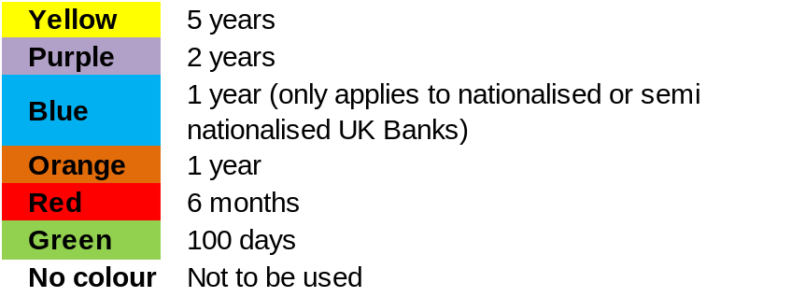

The yellow colour category is for UK Government debt, or its equivalent, money market funds and collateralised deposits where the collateral is UK Government debt.

The Link Asset Services’ creditworthiness service uses a wider array of information other than just primary ratings. Furthermore, by using a risk weighted scoring system, it does not give undue preponderance to just one agency’s ratings.

Typically, the minimum credit ratings criteria the Council use will be a Short-Term rating (Fitch or equivalents) of F1 and a Long Term rating of A-. There may be occasions when the counterparty ratings from one rating agency are marginally lower than these ratings but may still be used. In these instances, consideration will be given to the whole range of ratings available, or other topical market information, to support their use.

All credit ratings will be monitored weekly and will be checked at the time of placing investments. The Council is alerted to changes to ratings of all three agencies through its use of the Link Asset Services’ creditworthiness service, and has access to the websites of Fitch, Moody’s and Standard & Poor’s.

- if a downgrade results in the counterparty / investment scheme no longer meeting the Council’s minimum criteria, its further use as a new investment will be withdrawn immediately.

- in addition to the use of credit ratings the Council will be advised of information in movements in credit default swap spreads against the iTraxx benchmark and other market data on a daily basis via its Passport website, provided exclusively to it by Link Asset Services. Extreme market movements may result in downgrade of an institution or removal from the Council’s lending list.

Sole reliance will not be placed on the use of this external service. In addition, this Council will also use market data and market information, information on any external support for banks to help support its decision-making process.

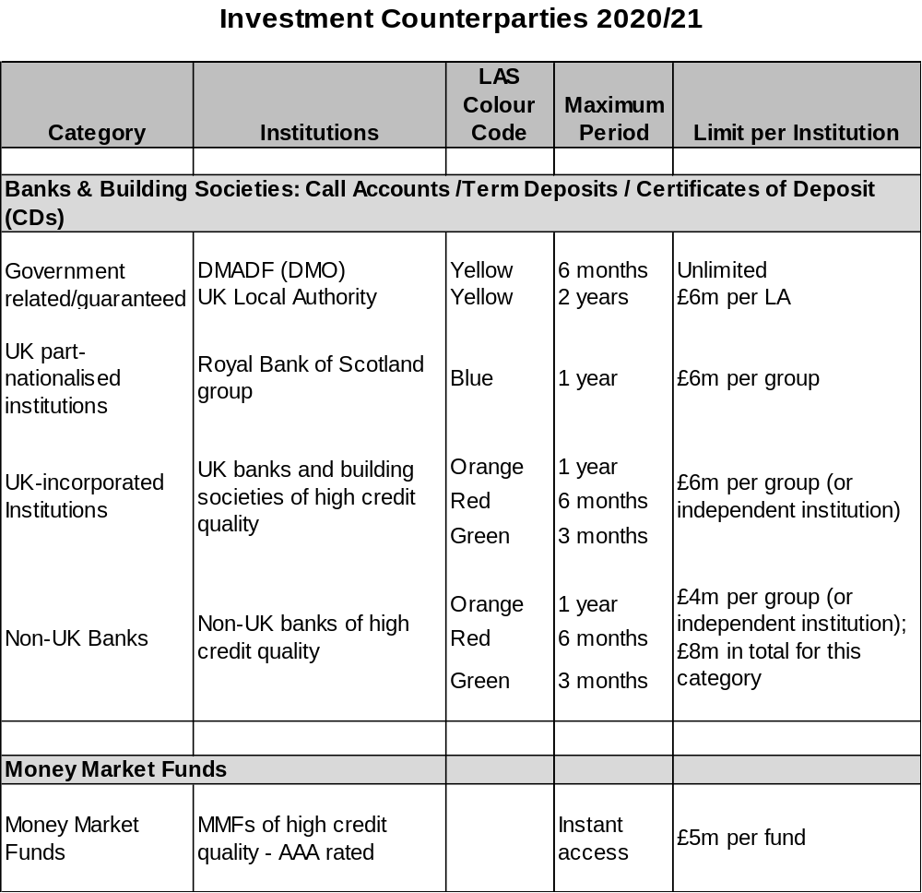
  - Country limits

In the 2019/20 Strategy, the Council determined that, in addition to UK counterparties, it would use non-UK banks, but only those which are in EU countries with a minimum sovereign credit rating of AA- from Fitch. This provision has been in place since 2015/16, when the Council first reintroduced allowance for the use of non-UK counterparties. This has been reviewed and it is recommended that, while all other criteria, i.e.:
- the requirement for the country concerned to have minimum sovereign rating of AA-,
- the requirement for the individual institution to have a high credit rating (see 8.2), and
- the overall limits on non-UK banks of £4m per institution/group and £8m in total in this category of investment,
shall remain unchanged, the restriction to only EU countries be removed. This is based on advice received in respect of the latest assessments of the strength of the regulatory frameworks in those countries.

The list of eligible countries at the date of this report would then be as shown below. This list will be added to, or deducted from, by officers should ratings change in accordance with this policy.

In operational terms, the change is likely to have only limited impact. The only non-UK counterparty used in the last three years is the German bank Landesbank Hessen-Thüringen Girozentrale (Helaba). The Council currently has the maximum amount of £4m invested with this counterparty.

APPROVED COUNTRIES FOR INVESTMENTS – United Kingdom plus the following:

AAA
Australia
Canada
Denmark
Germany
Luxembourg
Netherlands
Norway
Singapore
Sweden
Switzerland

AA+
Finland
U.S.A.

AA
Abu Dhabi (UAE)
Hong Kong
France

AA-
Belgium

  - Investment strategy

In-house funds
Investments will be made with reference to the core balance and cash flow requirements and the outlook for short-term interest rates (i.e. rates for investments up to 12 months).

Investment returns expectations
Bank Rate is forecast to increase steadily but slowly over the next few years to reach 2.00% by quarter 1 2022. Bank Rate forecasts for financial year ends (March) are:

- 2019/20 0.75% Was 1.25% in 2019/20 Treasury Strategy report
- 2020/21 0.75% Was 1.50%
- 2021/22 1.00% Was 2.00%
- 2021/22 1.25%

The suggested budgeted investment earnings rates for returns on investments placed for periods up to about three months during each financial year are as follows:

 | Now |  | 2019/20 report
2019/20 | 0.75% |  | 0.90%
2020/21 | 0.75% |  | 1.25%
2021/22 | 1.00% |  | 1.50%
2022/23 | 1.25% |  | 1.75%
2023/24 | 1.50% |  | 2.00%
2024/25 | 1.75% |  | 2.75%
Later years | 2.25% |  | 2.75%

The overall balance of risks to economic growth in the UK is probably to the downside due to the weight of all the uncertainties over Brexit, as well as a softening global economic picture. The balance of risks to increases in Bank Rate and shorter term PWLB rates are broadly similarly to the downside.

Investment Treasury Indicator and limit - total principal funds invested for greater than 365 days. These limits are set with regard to the Council’s liquidity requirements and to reduce the need for early sale of an investment and are based on the availability of funds after each year-end.

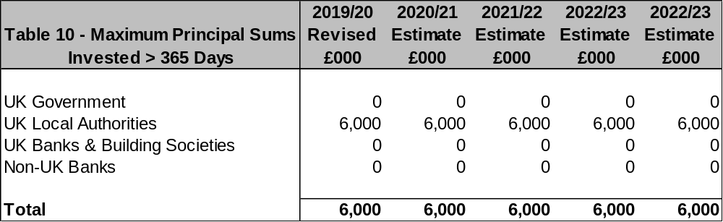
For its cash flow generated balances, the Council will seek to utilise its business reserve instant access and notice accounts, money market funds and short-dated deposits (overnight to 100 days) in order to benefit from the compounding of interest.

  - Investment Risk Benchmarking

This Council will use an investment benchmark to assess the investment performance of its investment portfolio of 7-day LIBID plus 1.5%.

  - End of Year Investment Report

At the end of the financial year, the Council will report on its investment activity as part of its Annual Treasury Report.

  - Accounting treatment of investments

The accounting treatment may differ from the underlying cash transactions arising from investment decisions made by this Council. To ensure that the Council is protected from any adverse revenue impact, which may arise from these differences, officers will review the accounting implications of new transactions before they are undertaken.

- BACKGROUND DOCUMENTS

CIPFA Treasury Management in the Public Services: Code of Practice & Cross-Sectoral Guidance Notes (December 2017 edition)
CIPFA Treasury Management in the Public Services: Guidance Notes for Local Authorities (July 2018 edition)
CIPFA Prudential Code for Capital Finance in Local Authorities (December 2017 edition)
CIPFA Standards of Professional Practice: Treasury Management
MHCLG Guidance on Local Government Investments
MHCLG Guidance on Minimum Revenue Provision

APPENDIX D1 – Economic Background
APPENDIX D2 – Interest Rate Forecasts
APPENDIX D3 – Comparison of Interest Rate Forecasts

ECONOMIC BACKGROUND

Advice from Link Asset Services:

UK: Brexit. The formal departure of the UK from the EU took place on 31 January 2020, but remains much uncertainty in respect of the detail of the country’s future trading relationship with the bloc, with the trade deal to determine this will need to be negotiated by the currently scheduled end of the transition period in December 2020, which the Prime Minister has pledged he will not extend. This is a challenging timeframe for such major negotiations and a failure to complete them on time would leave open two possibilities; i.e. the need for an extension of negotiations, perhaps of as much as two years, or a no deal outcome at the end of December 2020.

UK: GDP growth has taken a hit from Brexit uncertainty during 2019; although quarter three 2019 surprised on the upside by coming in at +0.4% q/q, +1.1% y/y. However, the peak of Brexit uncertainty during the final quarter appears to have suppressed quarterly growth, probably to around zero. The economy is likely to tread water in 2020, with only limited growth around about 1% until there is more certainty after the trade deal deadline has passed.

While the Bank of England did produce its regular Quarterly Inflation Report (now renamed the Monetary Policy Report) on 7 November, this was always to be overtaken by events, to one extent or another, given the then-current uncertainties associated with the then-forthcoming general election. The Bank did make a change in their Brexit assumptions, to now include a deal being eventually passed. Possibly the most significant message was that of an increase in concerns among MPC members around weak global economic growth and the potential for Brexit uncertainties to become entrenched and so delay UK economic recovery. Consequently, the MPC voted 7-2 to maintain the Bank Rate at 0.75% but two members were sufficiently concerned to vote for an immediate Bank Rate cut to 0.5%. The MPC warned that if global growth does not pick up or if uncertainties associated with Brexit intensify, then a rate cut would become more likely. Conversely, if risks recede, then a more rapid recovery of growth will require gradual and limited rate rises. The speed of recovery will depend on the extent to which uncertainty dissipates over the final terms for future trade between the UK and EU and by how much global growth rates pick up. The Bank revised its inflation forecasts down – to 1.25% in 2019, 1.5% in 2020, and 2.0% in 2021; hence, the MPC views inflation as causing little concern in the near future.

The MPC meeting of 19 December repeated the previous month’s vote of 7-2 to keep Bank Rate on hold. Their key view was that there was currently ‘no evidence about the extent to which policy uncertainties among companies and households had declined’. The two members who voted for a cut were concerned that the labour market was faltering. On the other hand, there was a clear warning in the minutes that the MPC were concerned that “domestic unit labour costs have continued to grow at rates above those consistent with meeting the inflation target in the medium term”. The voting pattern of 7-2 in favour of keeping rates on hold was again repeated at February’s MPC meeting, with some increased optimism around the stabilisation of the global economy, an easing in global trade tensions and some improved domestic data, but with continuing concerns about the short- and medium-term prospects for growth.

If economic growth were to weaken considerably, the MPC has relatively little room to make a big impact with Bank Rate still only at 0.75%. It would therefore probably suggest that it would be up to the Chancellor to provide help to support growth, by way of a fiscal boost, e.g. through tax cuts, increases in the annual expenditure budgets of government departments and services and expenditure on infrastructure projects. The Government has already made moves in this direction with significant promises in its election manifesto to increase government spending by up to £20bn p.a. (adding approximately 1% to GDP growth rates), by investing primarily in infrastructure. This is likely to be confirmed in the next Budget, in February or March 2020. The Chancellor also amended the fiscal rules in November to allow for an increase in government expenditure.

As for inflation itself, CPI has been hovering around the Bank of England’s target of 2% during 2019, but fell again in both October and November to a three-year low of 1.5% and then again to 1.3% in December. It is likely to remain close to or under 2% over the next two years and so does not pose any immediate concern to the MPC. However, if there was a hard or no deal conclusion to the trade talks with the EU, then inflation could rise towards 4%, primarily because of imported inflation on the back of a weakening pound.

With regard to the labour market, growth in numbers employed had been quite resilient through 2019 until the three months to September where it fell by 58,000. However, there was an encouraging pick up again in the three months to October, with growth of 24,000, indicating that the labour market was not about to head into a major downturn. The unemployment rate held steady at a 44-year low of 3.8% on the Independent Labour Organisation measure in October. Wage inflation has been steadily falling from a high point of 3.9% in July to 3.5% in October (3-month average regular pay, excluding bonuses). This meant that in real terms, (i.e. wage rates higher than CPI inflation), earnings grew by about 2.0%. As the UK economy is very much services sector driven, an increase in household spending power is likely to feed through into providing some support to the overall rate of economic growth in the coming months. The other message from the fall in wage growth is that employers are beginning to find it easier to hire suitable staff, indicating that supply pressure in the labour market is easing.

USA. President Trump’s massive easing of fiscal policy in 2018 fuelled a temporary boost in consumption in that year which generated an upturn in the rate of growth to a robust 2.9% y/y. Growth in 2019 has been falling after a strong start in quarter 1 at 3.1%, (annualised rate), to 2.0% in quarter 2 and then 2.1% in quarter 3. The economy looks likely to have maintained a growth rate similar to quarter 3 into quarter 4 and fears of a recession have largely dissipated. The strong growth in employment numbers during 2018 has weakened during 2019, indicating that the economy had been cooling, while inflationary pressures were also weakening. However, CPI inflation rose from 1.8% to 2.1% in November, a one year high, but this was caused exclusively by a rise in gasoline prices.

The Fed finished its series of increases in rates to 2.25 – 2.50% in December 2018. In July 2019, it cut rates by 0.25% as a ‘midterm adjustment’ but flagged up that this was not intended as the start of a series of cuts to ward off a downturn in growth. It also ended its programme of quantitative tightening in August, (reducing its holdings of treasuries etc.). It then cut rates by 0.25% again in September and by another 0.25% in its October meeting to 1.50 – 1.75%. At its September meeting it also said it was going to start buying Treasuries again, although this was not to be seen as a resumption of quantitative easing but rather an exercise to relieve liquidity pressures in the repo market. Despite those protestations, this still means that the Fed is again expanding its balance sheet holdings of government debt. In the first month, it will buy $60bn, whereas it had been reducing its balance sheet by $50bn per month during 2019. As it will be buying only short-term (under 12 months) Treasury bills, it is technically correct that this is not quantitative easing (which is purchase of long-term debt). The Fed left rates unchanged in December. However, the accompanying statement was more optimistic about the future course of the economy, so this would indicate that further cuts are unlikely.

Investor confidence has been seriously unsettled by the progressive increases in tariffs President Trump has made on Chinese imports, to which China has responded with increases in tariffs on its imports from the USA. This trade war is seen as depressing US, Chinese and world growth. In the EU, it is also particularly impacting Germany as exports of goods and services are equivalent to 46% of total GDP. It will also impact developing countries dependent on exporting commodities to China.
However, in November / December, progress was made on agreeing a phase one deal between the US and China to roll back some of the tariffs; giving some hope of resolving this dispute.

EUROZONE. Growth has been slowing from +1.8 % during 2018 to around half of that in 2019. Growth was +0.4% q/q (+1.2% y/y) in quarter 1, +0.2% q/q (+1.2% y/y) in quarter 2 and then +0.2% q/q, +1.1% in quarter 3. There appears to be little upside potential in the near future. German GDP growth has been struggling to stay in positive territory in 2019 and fell by -0.1% in quarter 2; industrial production was down 4% y/y in June with car production down 10% y/y. Germany would be particularly vulnerable to a failure of the UK/EU trade talks, which would depress exports further and also if President Trump were to impose tariffs on EU produced cars.

The European Central Bank (ECB) ended its programme of quantitative easing purchases of debt in December 2018. This meant that the central banks in the US, UK and EU had all ended the phase of post financial crisis expansion of liquidity, designed to support world financial markets by quantitative easing purchases of debt. However, the downturn in EZ growth in the second half of 2018 and into 2019, together with inflation falling well under the upper limit of its target range of 0 to 2%, (but which aims to keep it near to 2%), has prompted the ECB to take new measures to stimulate growth. At its March meeting it said that it expected to leave interest rates at their present levels “at least through the end of 2019”, but that was of little help to boosting growth in the near term. Consequently, it announced a third round of TLTROs; which provides banks with cheap borrowing every three months from September 2019 until March 2021. This means that, although they will have only a two-year maturity, the Bank was making funds available until 2023, two years later than under its previous policy. As with the last round, the new TLTROs will include an incentive to encourage bank lending, and they will be capped at 30% of a bank’s eligible loans. However, since then, the downturn in EZ and world growth has gathered momentum. At its meeting on 12 September the ECB cut its deposit rate further into negative territory, from -0.4% to -0.5%, and announced a resumption of quantitative easing purchases of debt for an unlimited period. At its October meeting it said these purchases would start in November at €20bn per month - a relatively small amount compared to the previous buying programme. It also increased the maturity of the third round of TLTROs from two to three years. However, it is doubtful whether this loosening of monetary policy will have much impact on growth and, unsurprisingly, the ECB stated that governments would need to help stimulate growth by ‘growth friendly’ fiscal policy.

There were no policy changes in the December meeting, which was chaired for the first time by the new President of the ECB, Christine Lagarde. However, the outlook continued to be downbeat about the economy; making it likely that there will be further monetary policy stimulus to come in 2020. It was also announced that there is to be a thorough review of how the ECB conducts monetary policy, including the price stability target. This review is likely to take the whole of 2020 to complete.

On the political front, Austria, Spain and Italy have seen the formation of coalition governments, with some unlikely combinations of parties, which in turn raises questions around their likely endurance. The latest results of German state elections has put further pressure on the German CDU/SDP coalition government and on the current leadership of the CDU. The results of the Spanish general election in November have not helped the prospects of forming a stable coalition.

CHINA. Economic growth has been weakening over successive years, despite repeated rounds of central bank stimulus. Medium term risks are increasing. Major progress still needs to be made to eliminate excess industrial capacity and the stock of unsold property, and to address the level of non-performing loans in the banking and shadow banking systems. In addition, there still needs to be a greater switch from investment in industrial capacity, property construction and infrastructure to consumer goods production.

JAPAN - has been struggling to stimulate consistent significant GDP growth and to get inflation up to its target of 2%, despite huge monetary and fiscal stimulus. It is also making little progress on fundamental reform of the economy.

WORLD GROWTH. Until recent years, world growth has been boosted by increasing globalisation i.e. countries specialising in producing goods and commodities in which they have an economic advantage and which they then trade with the rest of the world. This has boosted worldwide productivity and growth, and, by lowering costs, has also depressed inflation. However, the rise of China as an economic superpower over the last thirty years, which now accounts for nearly 20% of total world GDP, has unbalanced the world economy. The Chinese government has targeted achieving major world positions in specific key sectors and products, especially high-tech areas and production of rare earth minerals. It is achieving this by massive financial support (i.e. subsidies) to state owned firms, government directions to other firms, technology theft, restrictions on market access by foreign firms and informal targets for the domestic market share of Chinese producers in the selected sectors. This is regarded as being unfair competition that is putting western firms at an unfair disadvantage or even putting some out of business. It is also regarded with suspicion on the political front as China is an authoritarian country that is not averse to using economic and military power for political advantage. The current trade war between the US and China therefore needs to be seen against that backdrop. It is, therefore, likely that we are heading into a period where there will be a reversal of world globalisation and a decoupling of western countries from a dependence on China to supply products. This is likely to produce a backdrop in the coming years of weak global growth and so weak inflation. Central banks are, therefore, likely to come under more pressure to support growth by looser monetary policy measures and this will militate against central banks increasing interest rates.

The trade war between the US and China is a major concern to financial markets due to the synchronised general weakening of growth in the major economies of the world, compounded by fears that there could even be a recession looming up in the US, though this is probably overblown. These concerns resulted in government bond yields in the developed world falling significantly during 2019. If there were a major worldwide downturn in growth, central banks in most of the major economies will have limited options available, in terms of monetary policy measures, when rates are already very low in most countries (apart from the US). There are also concerns about how much distortion of financial markets has already occurred with the current levels of quantitative easing purchases of debt by central banks and the use of negative central bank rates in some countries. The latest PMI survey statistics of economic health for the US, UK, EU and China have all been predicting a downturn in growth; this confirms investor sentiment that the outlook for growth during the year ahead is weak.

INTEREST RATE FORECASTS

The interest rate forecasts provided by Link Asset Services are predicated on an assumption of an agreement being reached on Brexit between the UK and the EU. On this basis, while GDP growth is likely to be subdued in 2019 and 2020, due to all the uncertainties around Brexit depressing consumer and business confidence, an agreement on the detailed terms of a trade deal is likely to lead to provide a boost to the rate of growth in subsequent years. This could, in turn, increase inflationary pressures in the economy and so cause the Bank of England to resume a series of gentle increases in Bank Rate. Just how fast, and how far, those increases will occur and rise, will be data dependent. The forecasts in this report assume a modest recovery in the rate and timing of stronger growth and in the corresponding response by the Bank in raising rates.
- In the event of an orderly non-agreement exit in December 2020, it is likely that the Bank of England would take action to cut Bank Rate from 0.75% in order to help economic growth, to deal with the adverse effects of this situation. This is also likely to cause short to medium term gilt yields to fall.
- If there were a disorderly Brexit, then any cut in Bank Rate would be likely to last for a longer period and also depress short and medium gilt yields correspondingly. Quantitative easing could also be restarted by the Bank of England. It is also possible that the government could act to protect economic growth by implementing fiscal stimulus.

The balance of risks to the UK
- The overall balance of risks to economic growth in the UK is probably even, but dependent on a successful outcome of negotiations with the EU on a future trade deal.
- The balance of risks to increases in Bank Rate and shorter term PWLB rates are broadly similarly to the downside.
- In the event that a Brexit deal was agreed with the EU and approved by Parliament, the balance of risks to economic growth and to increases in Bank Rate is likely to change to the upside.

One risk that is both an upside and downside risk, is that all central banks are now working in very different economic conditions than before the 2008 financial crash, as there has been a major increase in consumer and other debt, due to the exceptionally low levels of borrowing rates that have prevailed since 2008. This means that the neutral rate of interest in an economy (i.e. the rate that is neither expansionary nor deflationary) is difficult to determine definitively in this new environment, although central banks have made statements that they expect it to be much lower than before 2008. Central banks could therefore either over- or under-do increases in central interest rates.

Downside risks to current forecasts for UK gilt yields and PWLB rates currently include:
- Brexit – if it were to cause significant economic disruption and a major downturn in the rate of growth.
- Bank of England takes action too quickly, or too far, over the next three years to raise Bank Rate and causes UK economic growth, and increases in inflation, to be weaker than we currently anticipate.
- A resurgence of the Eurozone sovereign debt crisis. In 2018, Italy was a major concern due to having a populist coalition government which made a lot of anti-austerity and anti-EU noise. However, in September 2019 there was a major change in the coalition governing Italy, which has brought to power a much more EU friendly government. This has eased the pressure on Italian bonds. Only time will tell whether this new coalition, based on an unlikely alliance of two very different parties, will endure.
- Weak capitalisation of some European banks, particularly Italian banks.
- German minority government. In the German general election of September 2017, Angela Merkel’s CDU party was left in a vulnerable minority position dependent on the fractious support of the SPD party, as a result of the rise in popularity of the anti-immigration AfD party. The CDU has done badly in recent state elections, but the SPD has done particularly badly, and this has raised a major question mark over continuing to support the CDU. Angela Merkel has stepped down from being the CDU party leader, but intends to remain as Chancellor until 2021.
- Other minority EU governments. Austria, Finland, Sweden, Spain, Portugal, Netherlands and Belgium also have vulnerable minority governments dependent on coalitions which could prove fragile.
- Austria, the Czech Republic, Poland and Hungary now form a strongly anti-immigration bloc within the EU. There has also been rising anti-immigration sentiment in Germany and France.
- In October 2019, the IMF issued a report on the World Economic Outlook which flagged up a synchronised slowdown in world growth. However, it also flagged up that there was potential for a rerun of the 2008 financial crisis, but his time centred on the huge debt binge accumulated by corporations during the decade of low interest rates. This now means that there are corporates who would be unable to cover basic interest costs on some $19trn of corporate debt in major western economies, if world growth was to dip further than just a minor cooling. This debt is mainly held by the shadow banking sector i.e. pension funds, insurers, hedge funds, asset managers etc., who, when there is $15trn of corporate and government debt now yielding negative interest rates, have been searching for higher returns in riskier assets. Much of this debt is only marginally above investment grade so any rating downgrade could force some holders into a fire sale, which would then depress prices further and so set off a spiral down. The IMF’s answer is to suggest imposing higher capital charges on lending to corporates and for central banks to regulate the investment operations of the shadow banking sector. In October 2019, the deputy Governor of the Bank of England also flagged up the dangers of banks and the shadow banking sector lending to corporates, especially highly leveraged corporates, which had risen back up to near pre-2008 levels.
- Geopolitical risks, for example in North Korea, but also in Europe and the Middle East, which could lead to increasing safe haven flows.

Upside risks to current forecasts for UK gilt yields and PWLB rates
- Brexit – if agreement was reached all round that removed all threats of economic and political disruption between the EU and the UK.
- The Bank of England is too slow in its pace and strength of increases in Bank Rate and, therefore, allows inflationary pressures to build up too strongly within the UK economy, which then necessitates a later rapid series of increases in Bank Rate faster than we currently expect.
- UK inflation, whether domestically generated or imported, returning to sustained significantly higher levels causing an increase in the inflation premium inherent to gilt yields.

Comparison of Interest Rate Forecasts – Treasury Strategy 2019/22 – 2022/23 (Feb 2019), and Treasury Strategy 2020/21 – 2023/24 (Jan 2020)

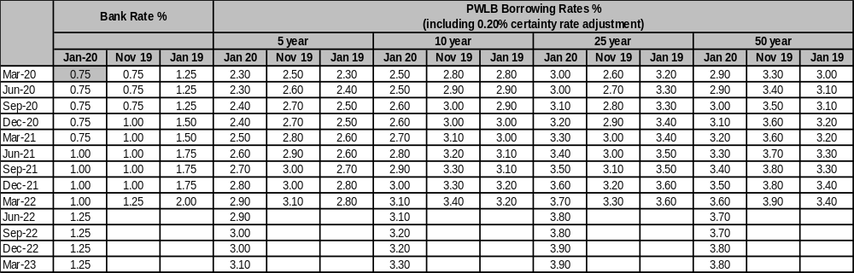

The February 2019 forecasts were included in Treasury Strategy 2019/20 to 2022/23.
Link Asset Services provided an updated forecast in January 2020.

